How to Add a Hard Drive inside Windows 2012

Note: Once a drive has been added via Cloud Concierge, Windows must initialize, partition, and format the drive in order to use it. The process is quite simple and will take less than 60 seconds to complete.
Step 1: Launch ‘Server Manager’
Step 2: Choose ‘Tools’ > ‘Computer Management’
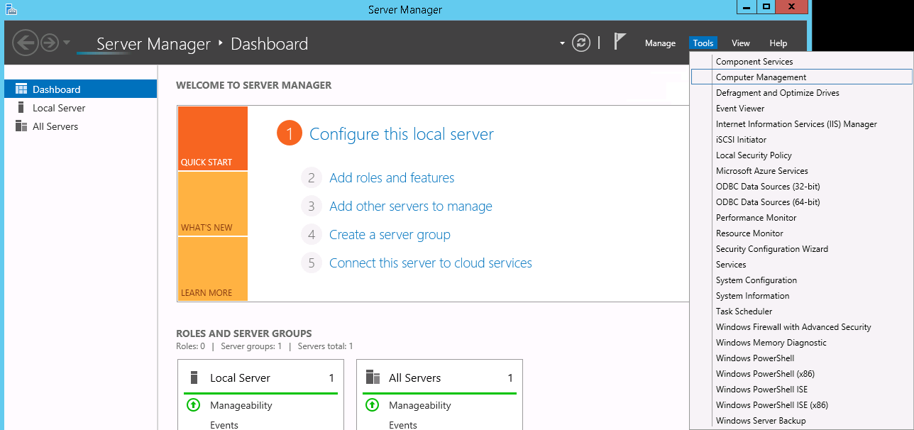
Step 3: Computer Management opens
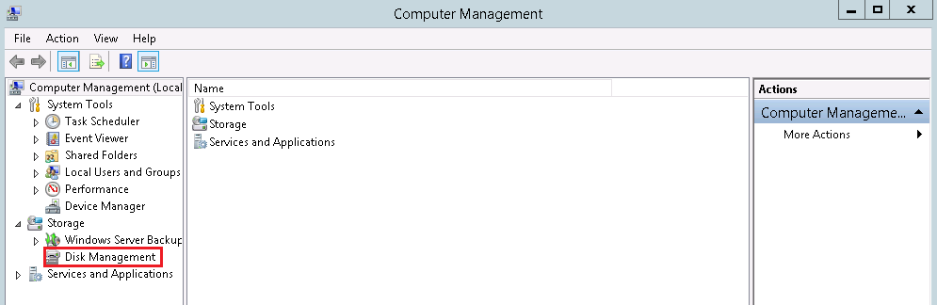
Step 4: Click ‘Disk Management’ on the left-hand navigation

Step 5: Windows immediately notices the new drive and prompts you to initialize it, click ‘OK’
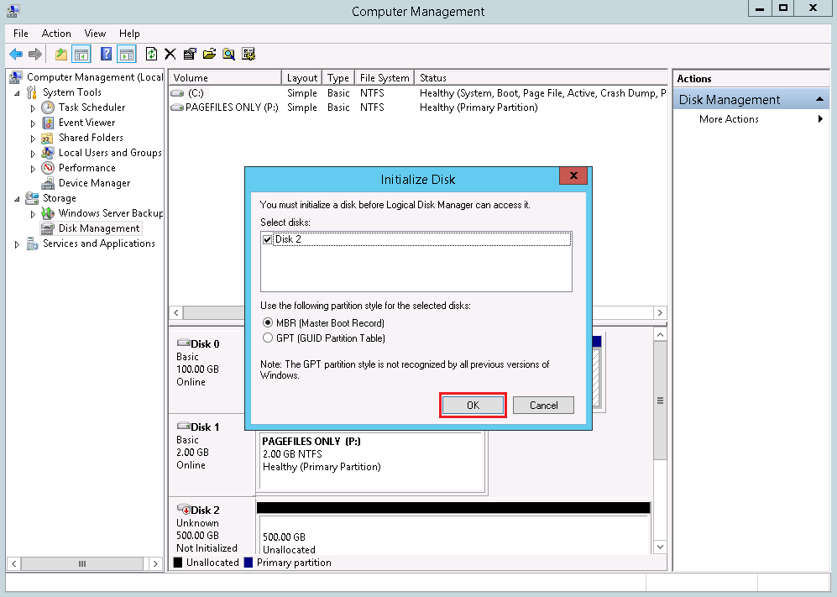
Step 6: Right click on the new Drive (Disk 2 in this example) and choose ‘New Simple Volume’
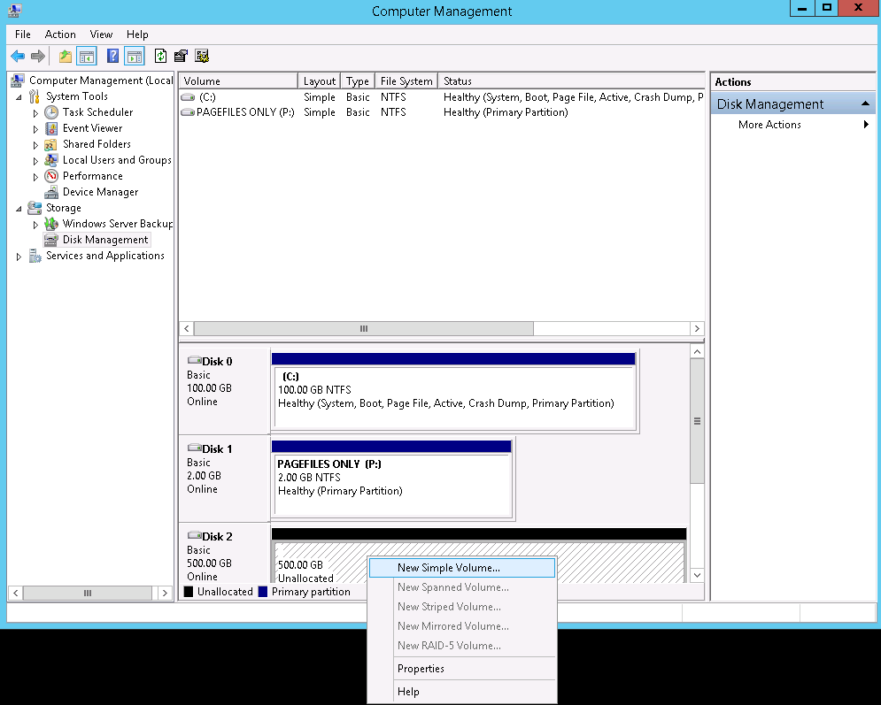

Step 7: The wizard opens and Click ‘Next’
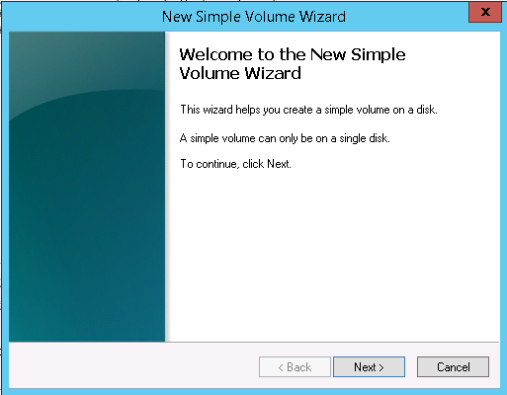
Step 8: Click ‘Next’
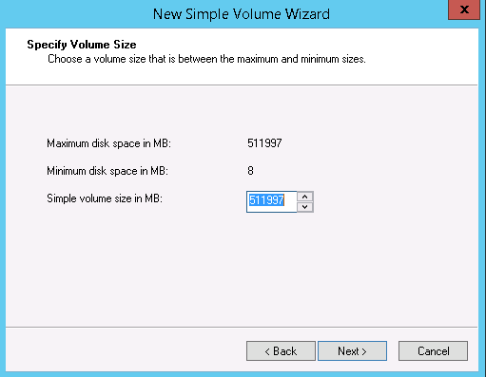

Step 9: Click ‘Next’
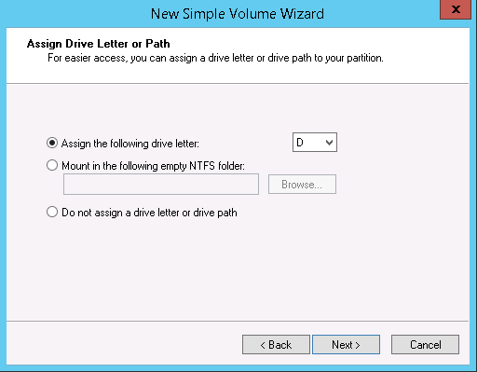
Step 10: Click ‘Next’
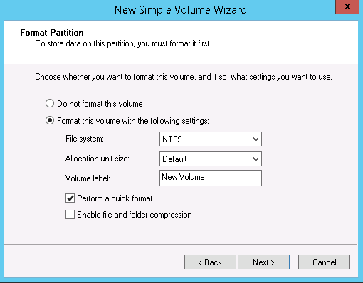
Step 11: Click ‘Finish’
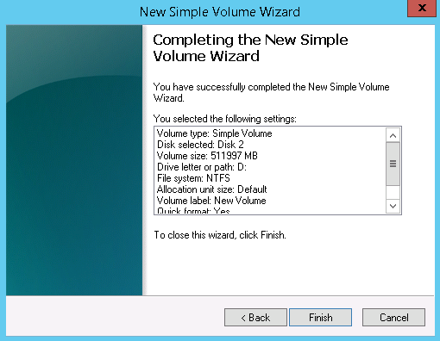

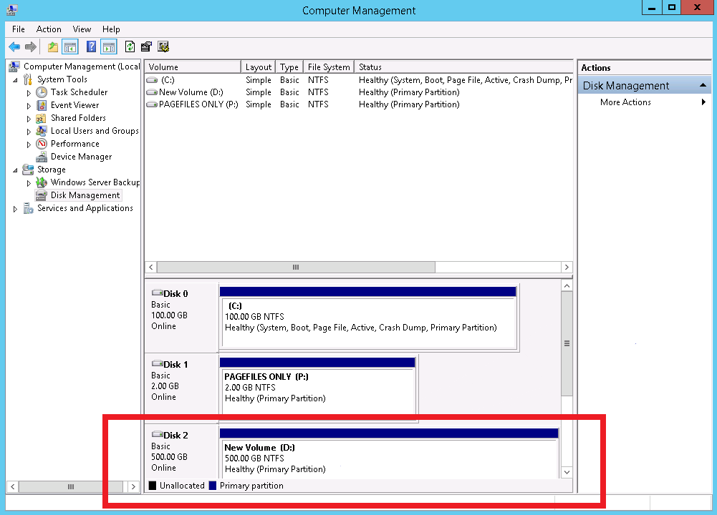
The new 500GB drive is formatted and ready to use as Drive D.

